TERRAFORM TASK – 03
- Execute the script shown in the video.
Environment variables:
export TF_VAR_filename="/root.pets.txt"
export TF_VAR_prefix= "MR"
SYNTAX --> Set-Item -Path env:TF_VAR_filename -Value 'wild.txt'
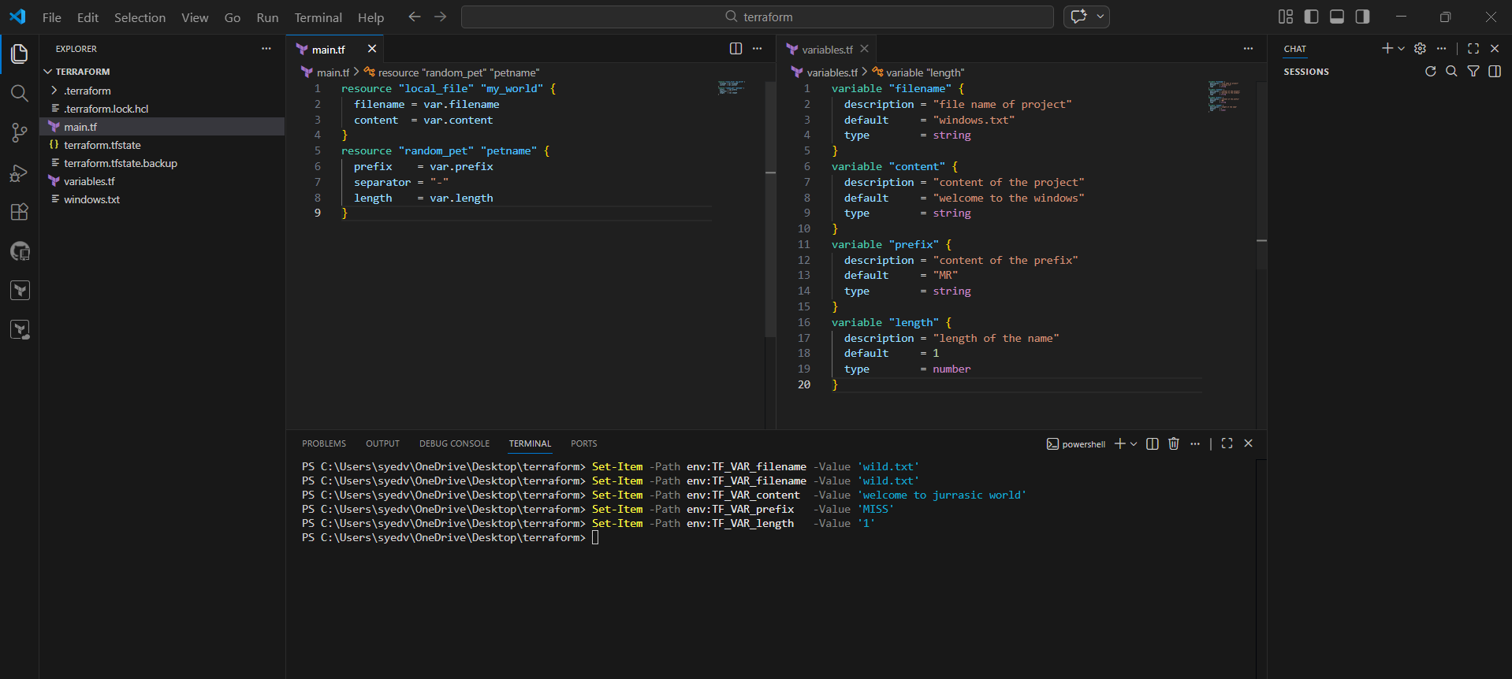
After passing the environment variables , perform terraform apply , it creates the file according to the Passed values in env variables.
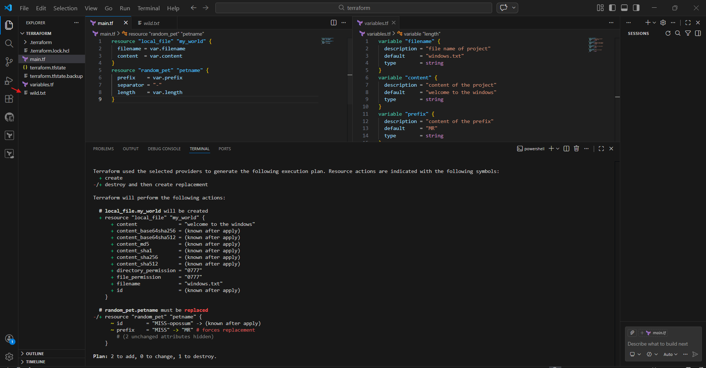

- Now I modified the “main.tf ” file .
- I need to get the pet_name created should be in the content of the file .
- To call the value ${resource.resource-name.id.}
${random_pet.petname.id} ---> random_pet = resource type, petname = resource name,
id = attribute.
- Perform terraform apply
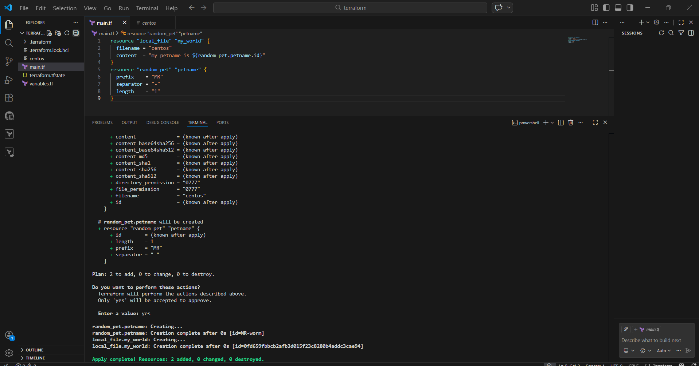
- The file got created ,
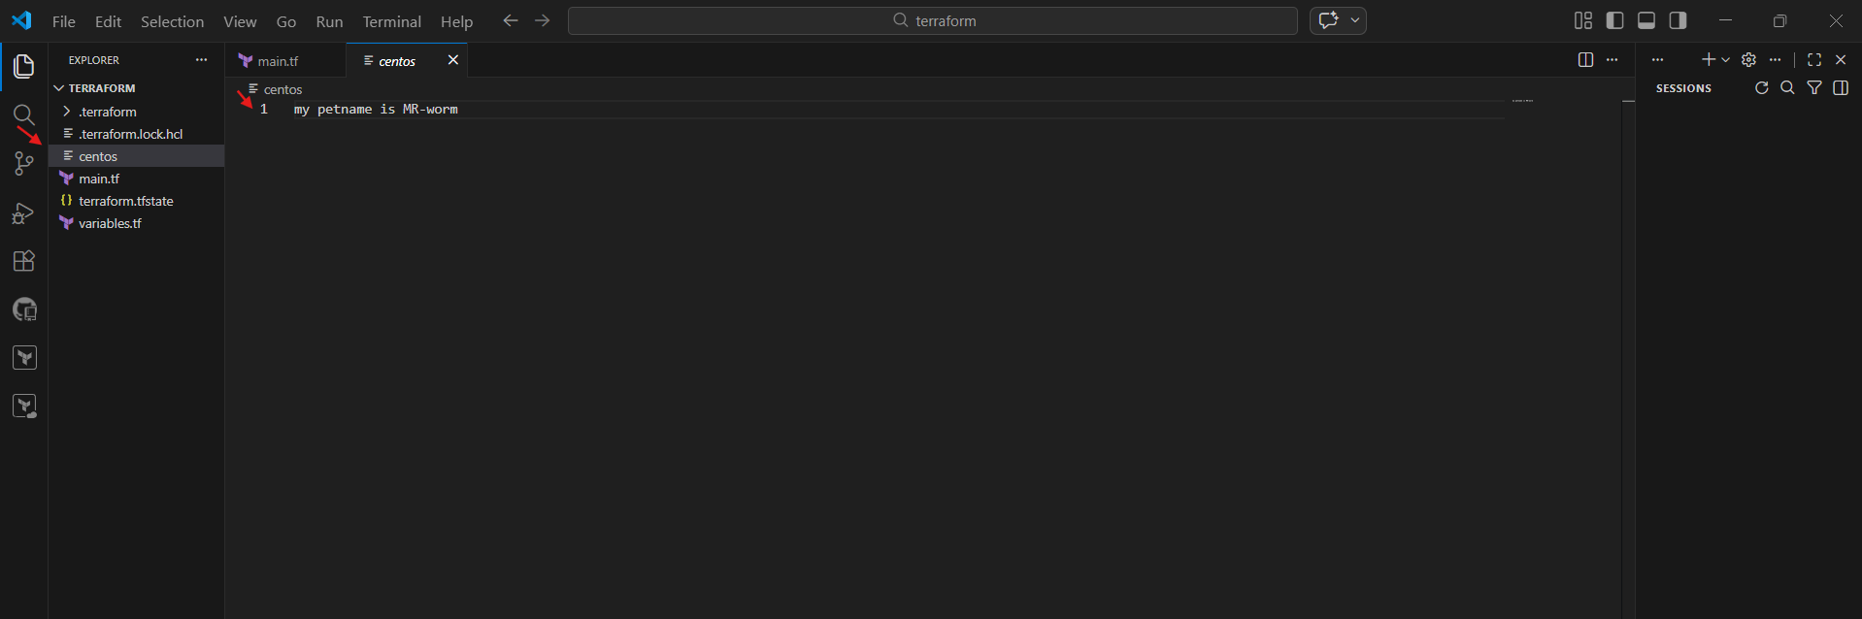
- Added output block in “main.tf” , perform terraform apply.
output "petname" {
value = random_pet.petname.id
}

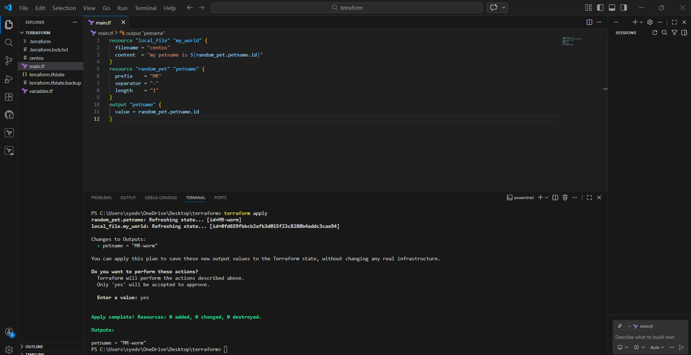
It shows the output as petname= “MR.flounder” ,
And also we can check outputs through command “terraform output”
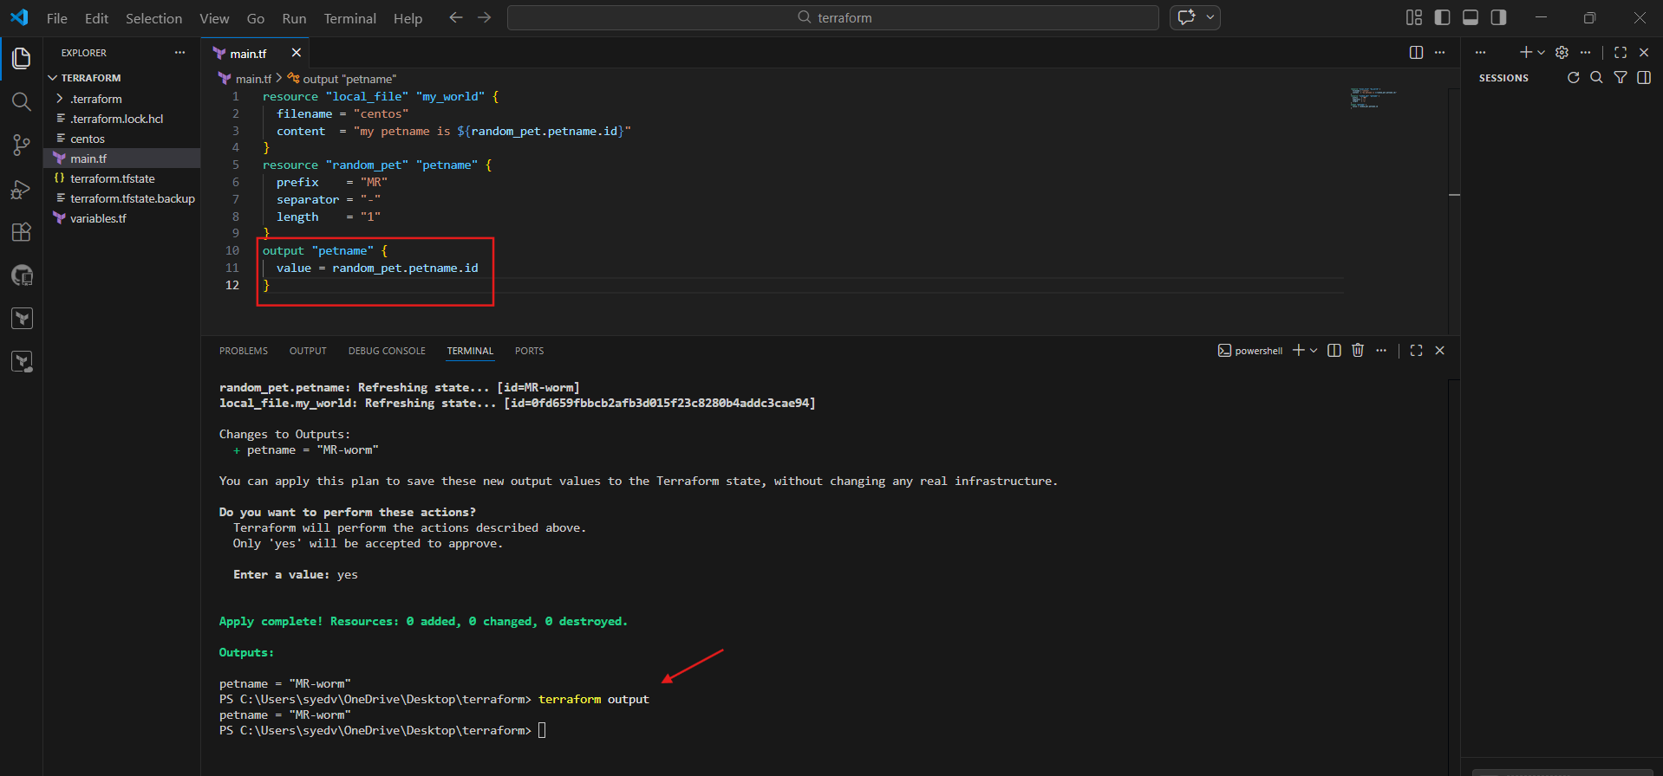

- Integrate Terraform in Jenkins using the Terraform plugin.

1. Prerequisites
Before starting, ensure the following are in place:
- Infrastructure & Software
* Jenkins installed and running
* Java (JDK 11 or 17 recommended)
* Terraform installed on Jenkins server **OR** use Terraform via Jenkins plugin
* Git installed on Jenkins server
* Access to a cloud provider (AWS / Azure / GCP)
- Jenkins Requirements
* Admin access to Jenkins
* Required Jenkins plugins:
* **Terraform Plugin**
* **Git Plugin**
* **Pipeline Plugin**
* **Credentials Binding Plugin**
- Source code management
* Git repository with Terraform code (main.tf, variables.tf, etc.)
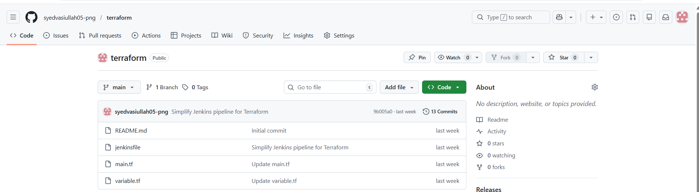
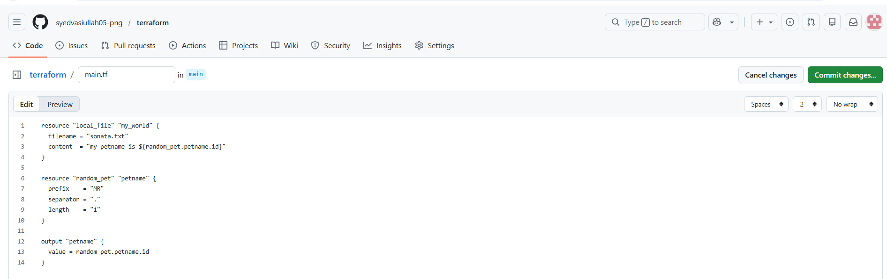

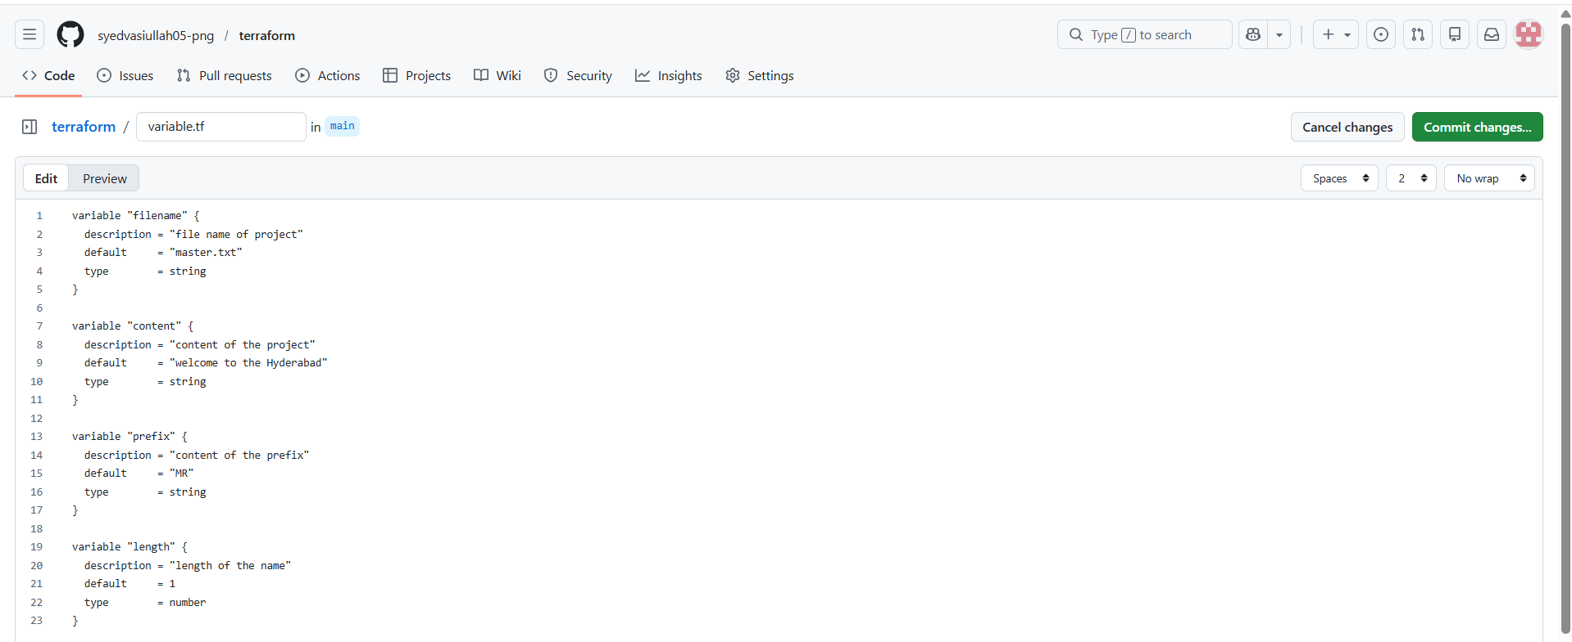

2. Step-by-Step Implementation
Step 1: Install Terraform , pipeline-stageview , git Plugin in Jenkins
1. Login to Jenkins → **Manage Jenkins** → **Manage Plugins**
2. Go to **Available**
3. Search for **Terraform Plugin , pipeline-stageview , git**
4. Install and restart Jenkins

Step 2: Configure Terraform Tool in Jenkins
1. Go to **Manage Jenkins** → **Global Tool Configuration**
2. Scroll to **Terraform**
3. Click **Add Terraform**
4. Provide:
* Name: `terraform`
* Install automatically (recommended) OR provide local Terraform path
5. Save

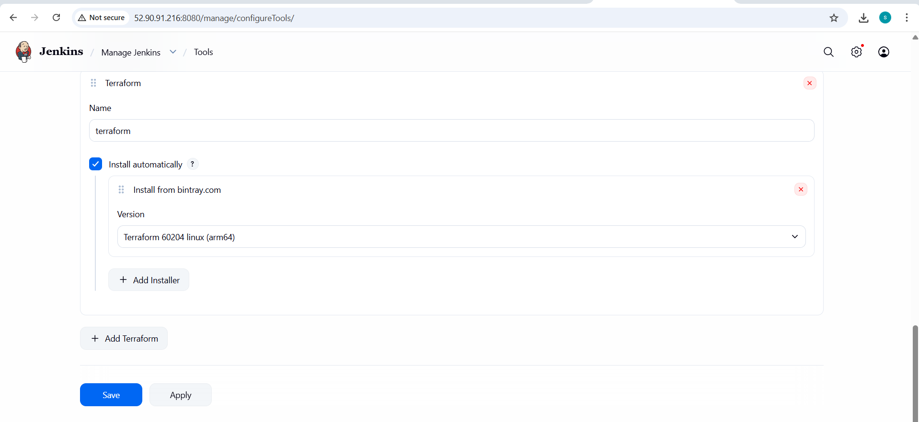
Step 3: Add Cloud Credentials in Jenkins
1. Go to **Manage Jenkins** → **Credentials**
2. Add new credentials:
* Kind: aws_credentials / acceskeyid & secret-accesskey
* ID: `aws-creds` (example)
3. Save

Step 4: Create Jenkins Pipeline Job
1. Go to Jenkins Dashboard → **New Item**
2. Select **Pipeline**
3. Name it: `terraform-pipeline
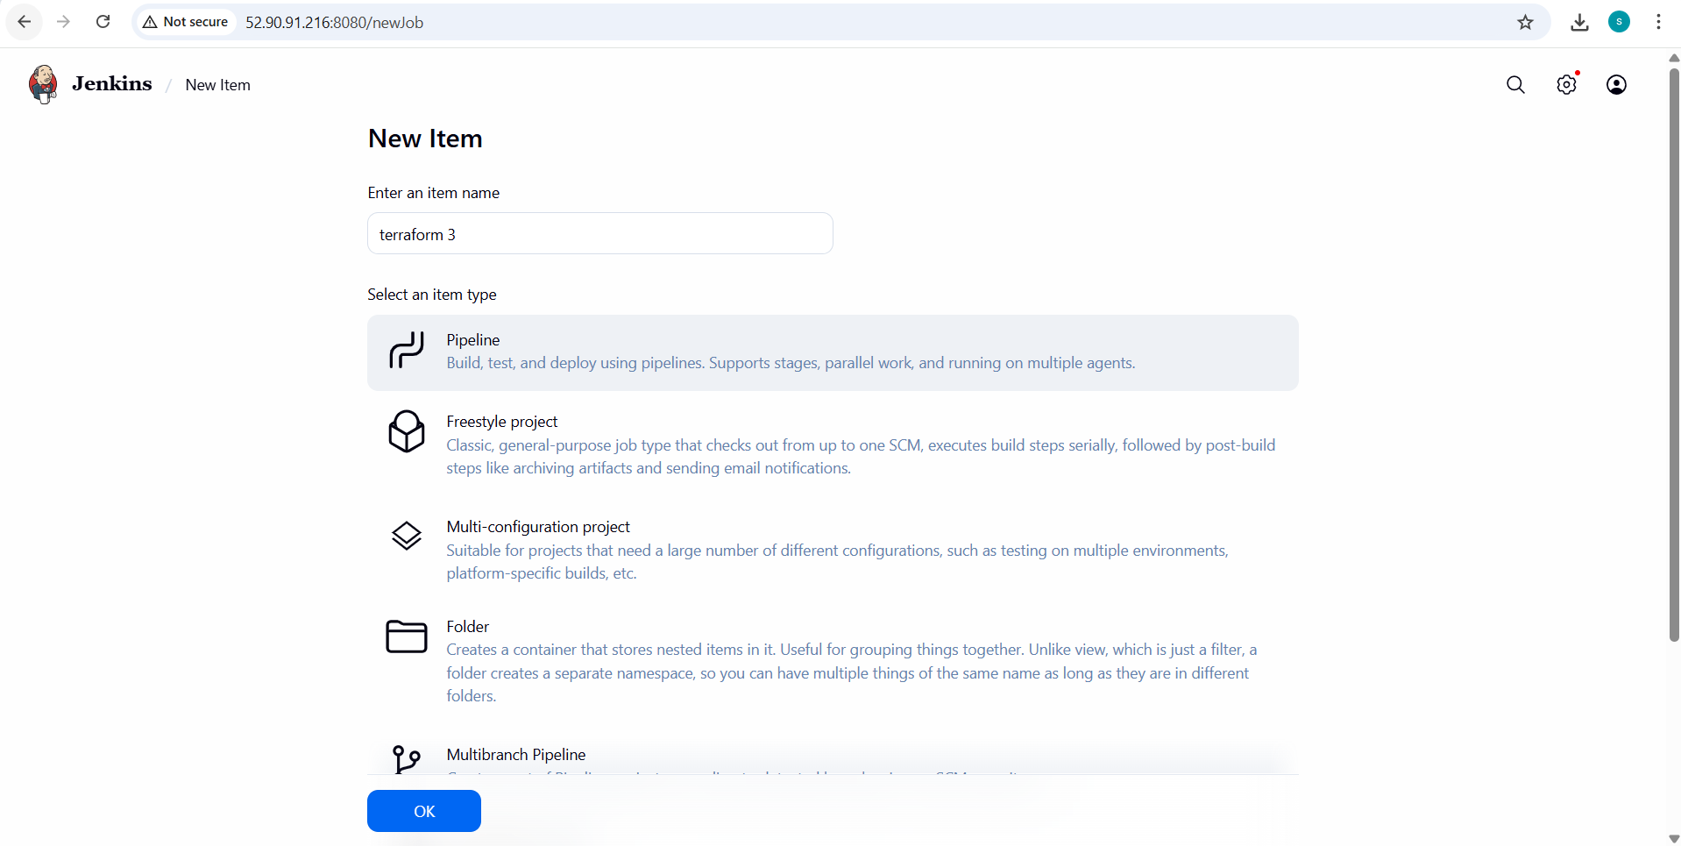
Step 5: Jenkinsfile (Pipeline Script)
Create a `jenkinsfile` in your Git repo:
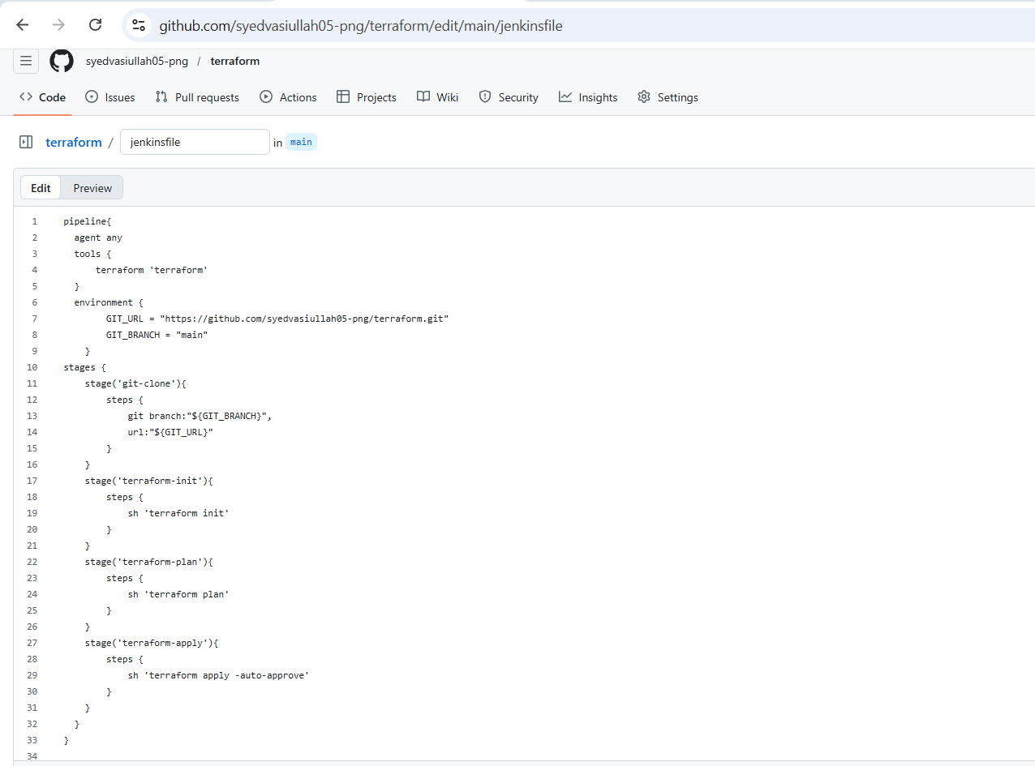
Step 6: Configure Git Repository in Jenkins Job

* In Pipeline job:

* Definition: **Pipeline script from SCM**
* SCM: Git
* Repository URL: your Terraform repo
* Branch: main
* Script Path: jenkinsfile

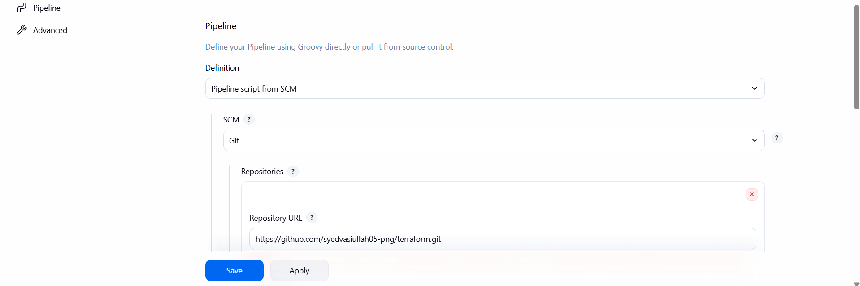

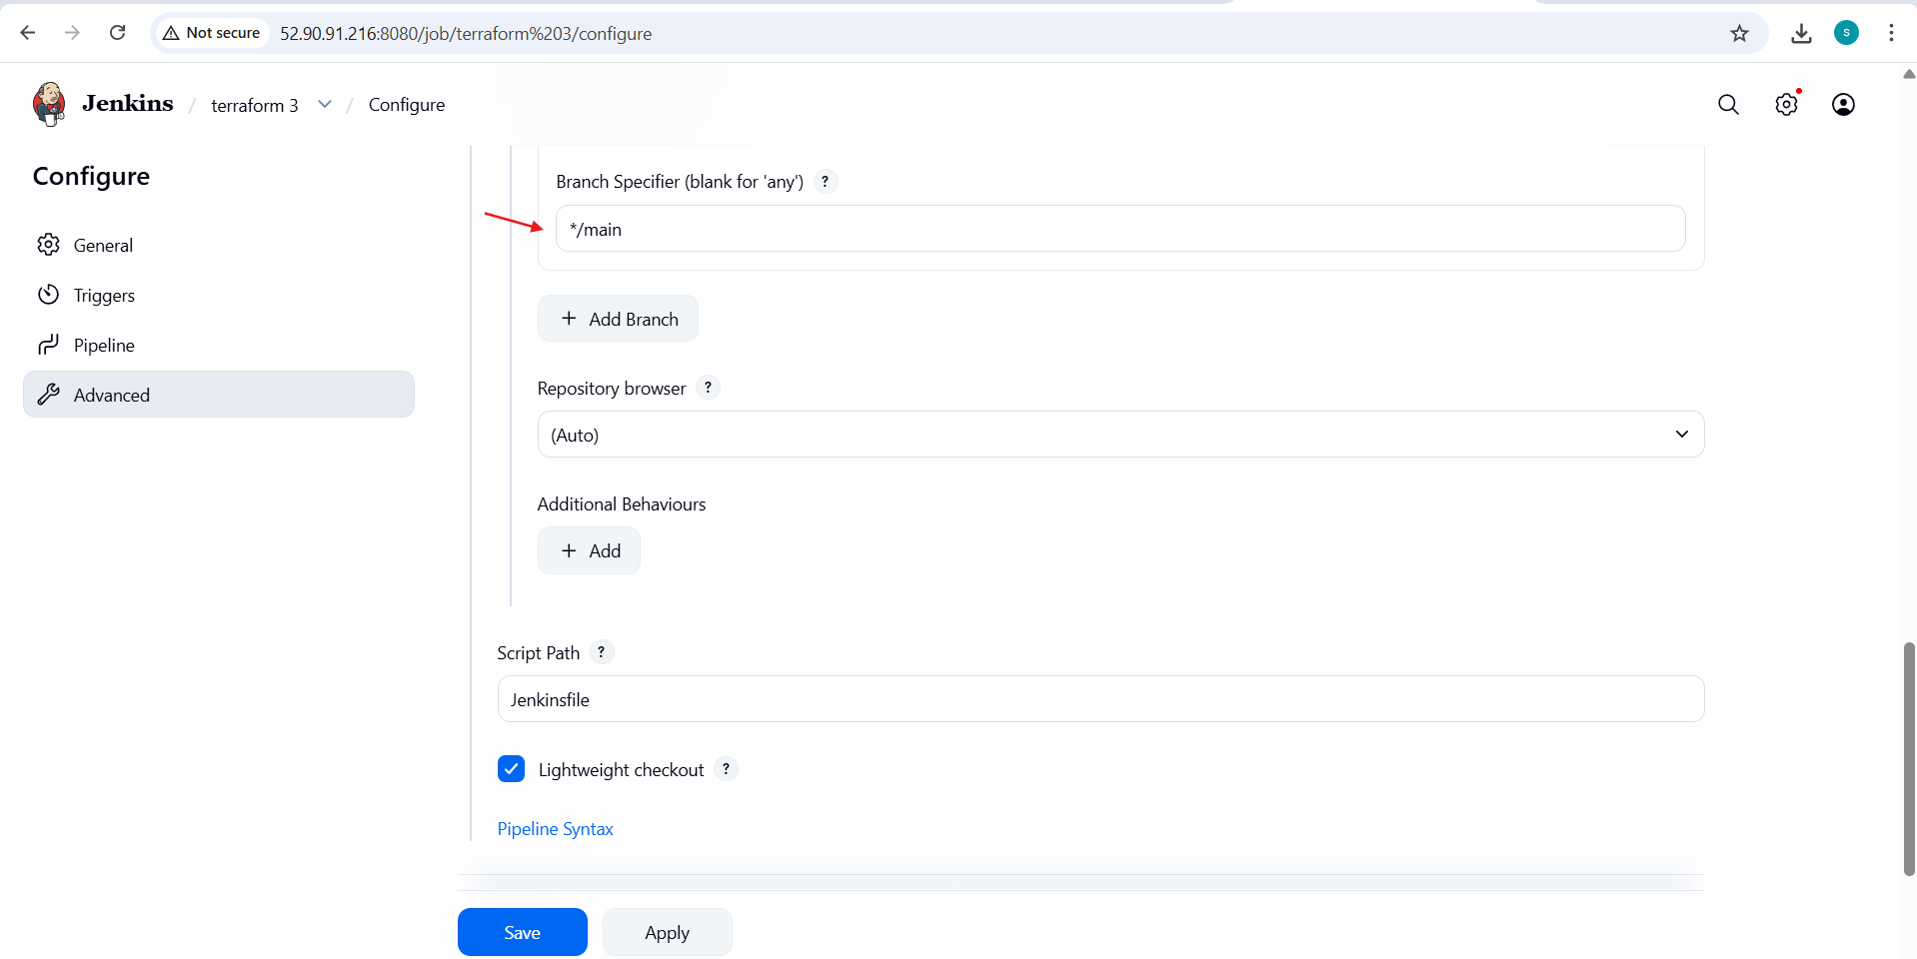

Step 7: Build the Job
Click **Build Now** to trigger the pipeline.

3. Validation Steps
Validation 1: Jenkins Console Output
Check Jenkins build logs for:
* `terraform init` completed successfully
* `terraform validate` passed
* `terraform plan` generated
* `terraform apply` executed without errors

Validation 2: Terraform State
Verify:
* `terraform.tfstate` created (locally or in remote backend like S3)

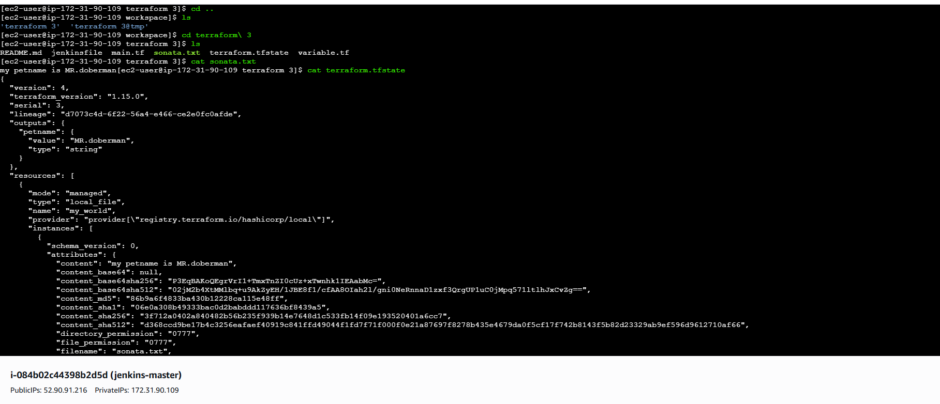
Validation 4: Jenkins UI
* Job status should be **SUCCESS**
* All stages should be green
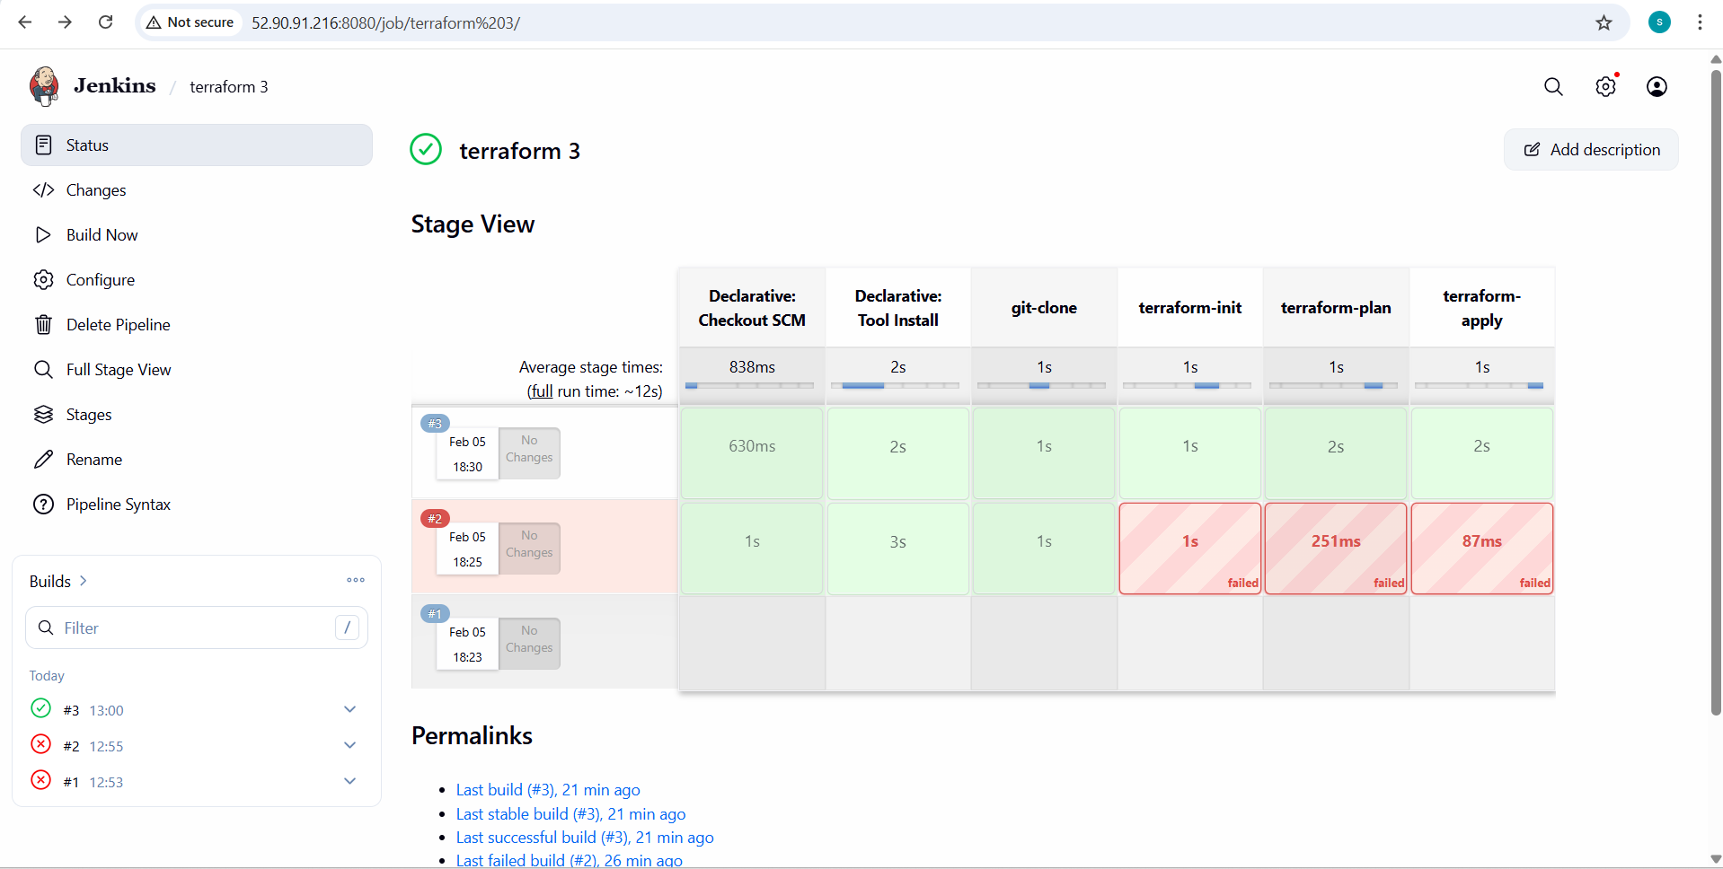

- Create one Jenkins job using Maven Project for the code below with two stages:

Stage 1: Git cloneStage
2: Maven Compilation Code:
https://github.com/betawins/java-Working-app.git
1. Prerequisites
- Before starting, ensure the following requirements are met:
Jenkins & System Requirements
* Jenkins installed and running
* Java JDK 8 or above installed on Jenkins server
* Maven installed on Jenkins server
* Git installed on Jenkins server
Jenkins Plugins
- Ensure these plugins are installed:
* **Git Plugin**
* **Maven Integration Plugin**
* **Pipeline (optional, but not needed here)**

- Tool Configuration in Jenkins
Configured under **Manage Jenkins → Global Tool Configuration**:
* JDK (e.g., `jdk11`)
* Maven (e.g., `maven3`)
* Git
- Repository
* GitHub repo URL:
`https://github.com/betawins/java-Working-app.git`

2. Step-by-Step Implementation
Step 1: Configure Tools in Jenkins
1. Go to **Manage Jenkins → Global Tool Configuration**
2. Configure:
* JDK → Name: `jdk11`
* Maven → Name: `maven3`
* Git → default
3. Save
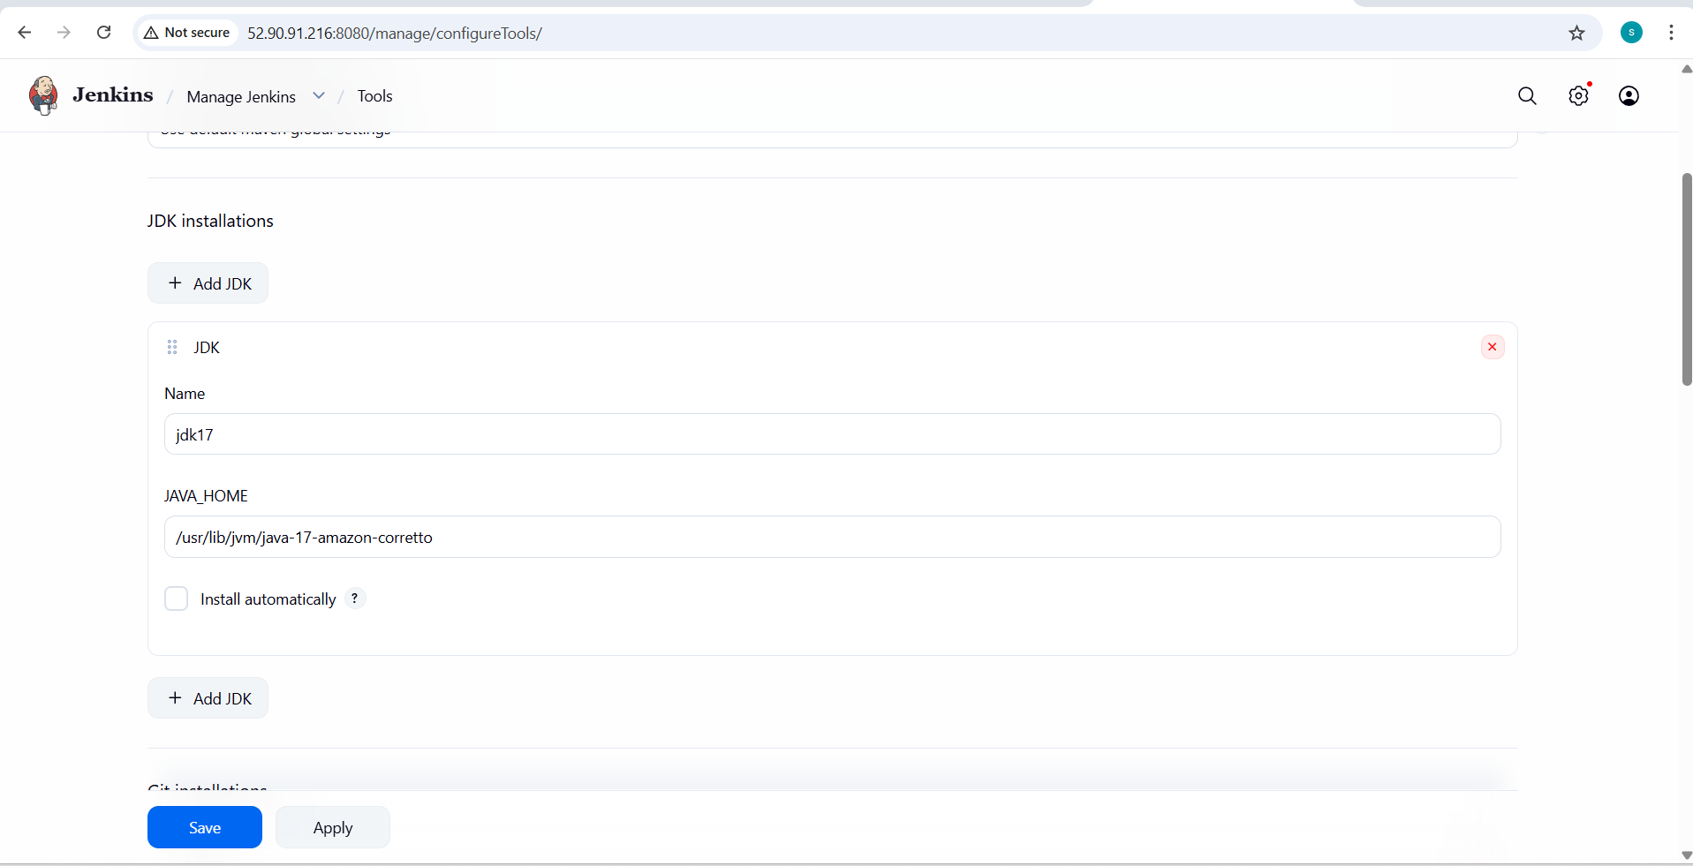

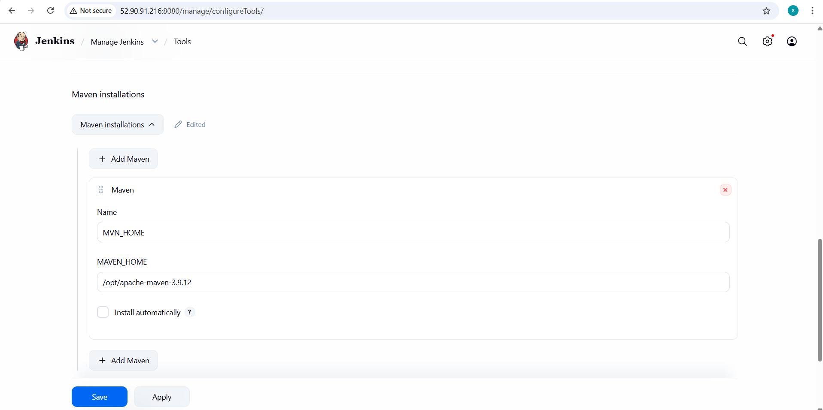
Step 2: Create Maven Project Job
1. Go to Jenkins Dashboard
2. Click **New Item**
3. Enter Job name:
`java-maven-build`
4. Select **Maven Project**
5. Click **OK**

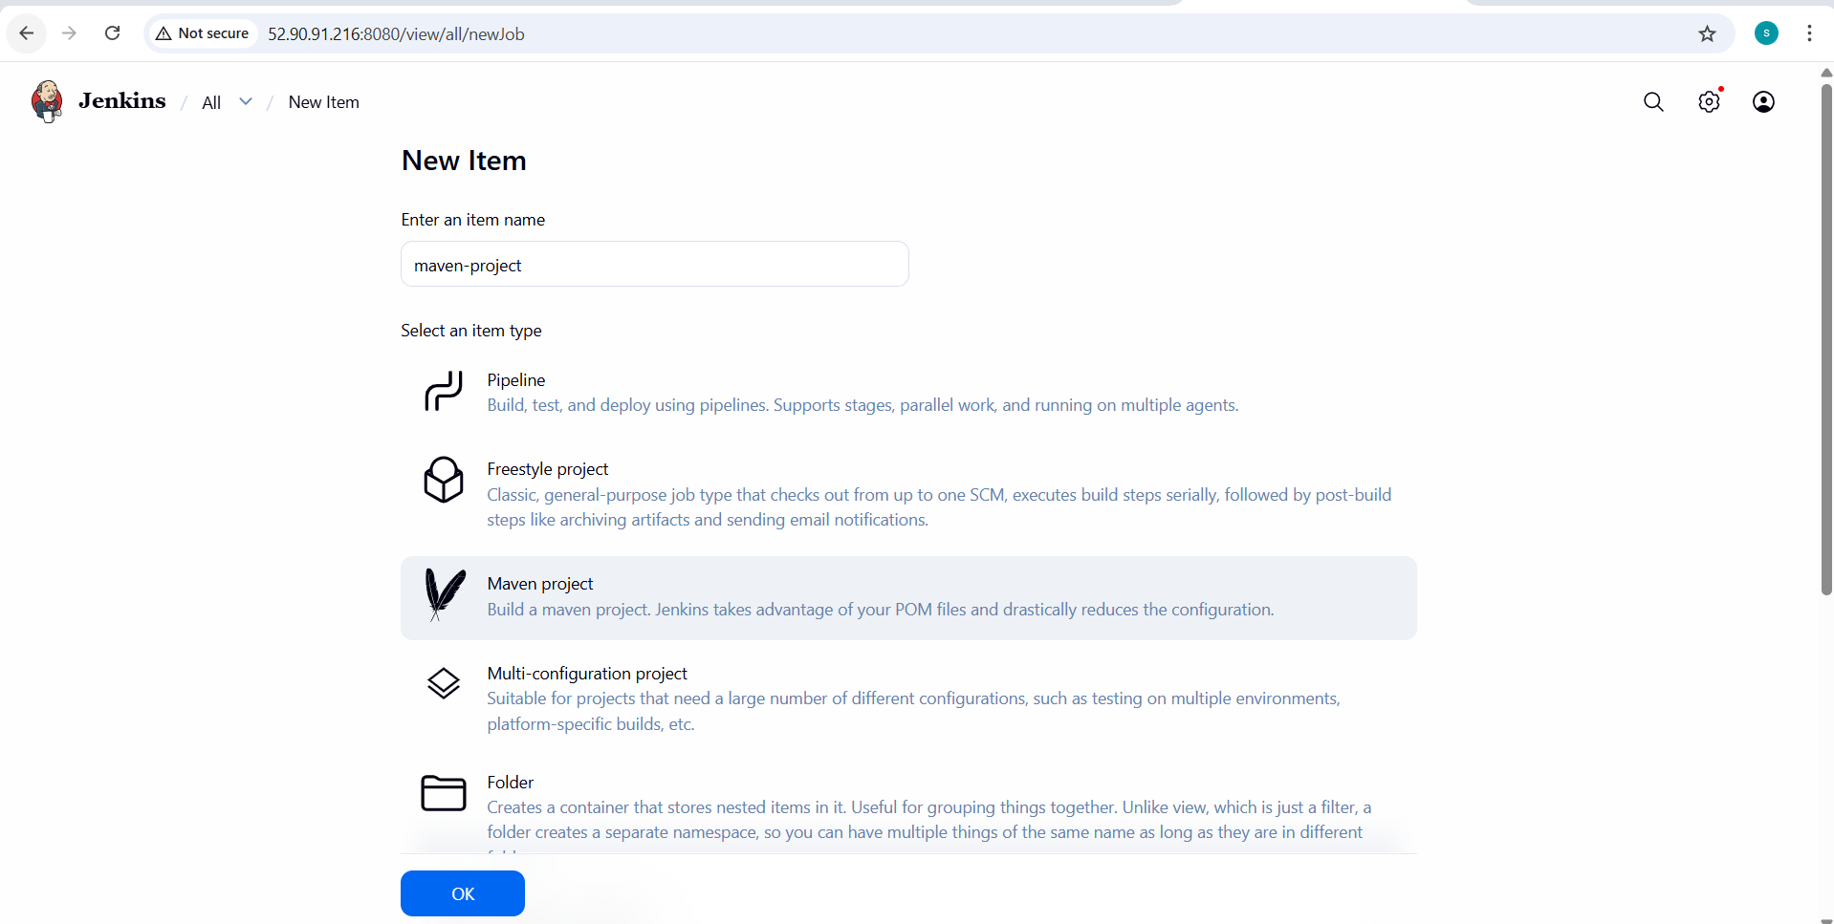
Step 3: Configure Git Repository (Stage 1: Git Clone)
In job configuration:
1. Under **Source Code Management**
* Select **Git**
* Repository URL:
https://github.com/betawins/java-Working-app.git
* Branch:
*/main

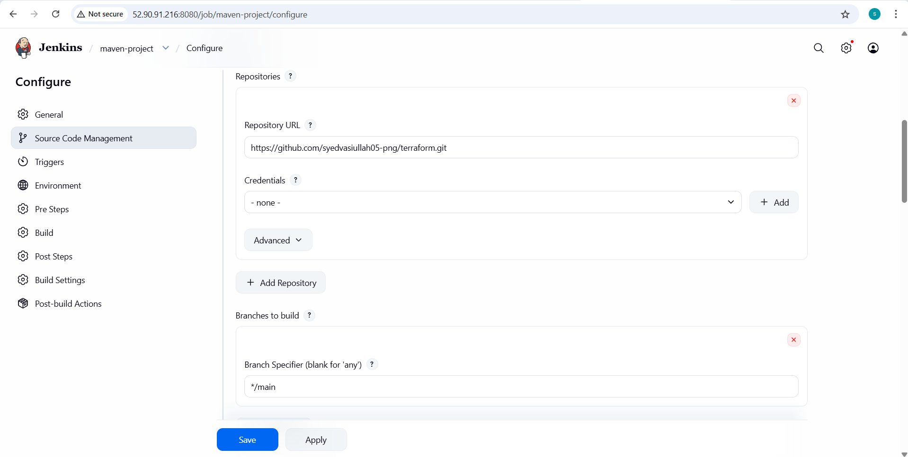
This automatically performs **Git Clone** as Stage 1.
### Step 4: Configure Build Environment
Under **Build Environment**:
* Check:
* Delete workspace before build starts (optional)
* Use specific JDK → select `jdk11`

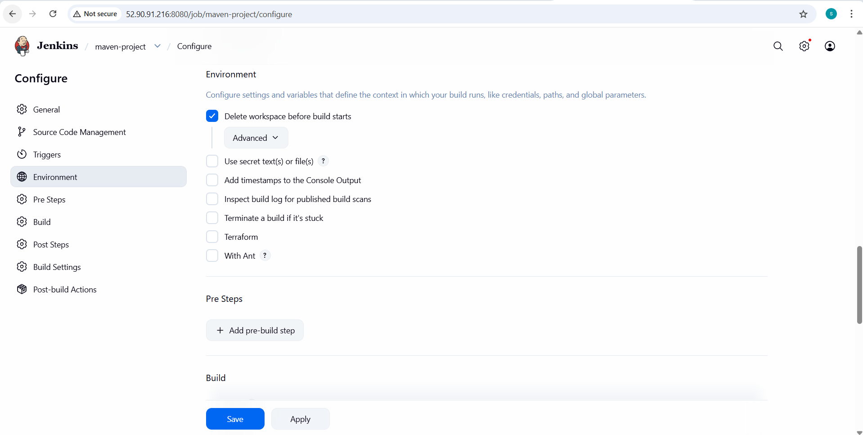

Step 5: Configure Maven Build (Stage 2: Maven Compilation)
Under **Build** section:
1. Select:
* **Invoke top-level Maven targets**
2. Maven Version: `maven3`
3. Goals:
clean compile
This performs **Maven Compilation** as Stage 2.

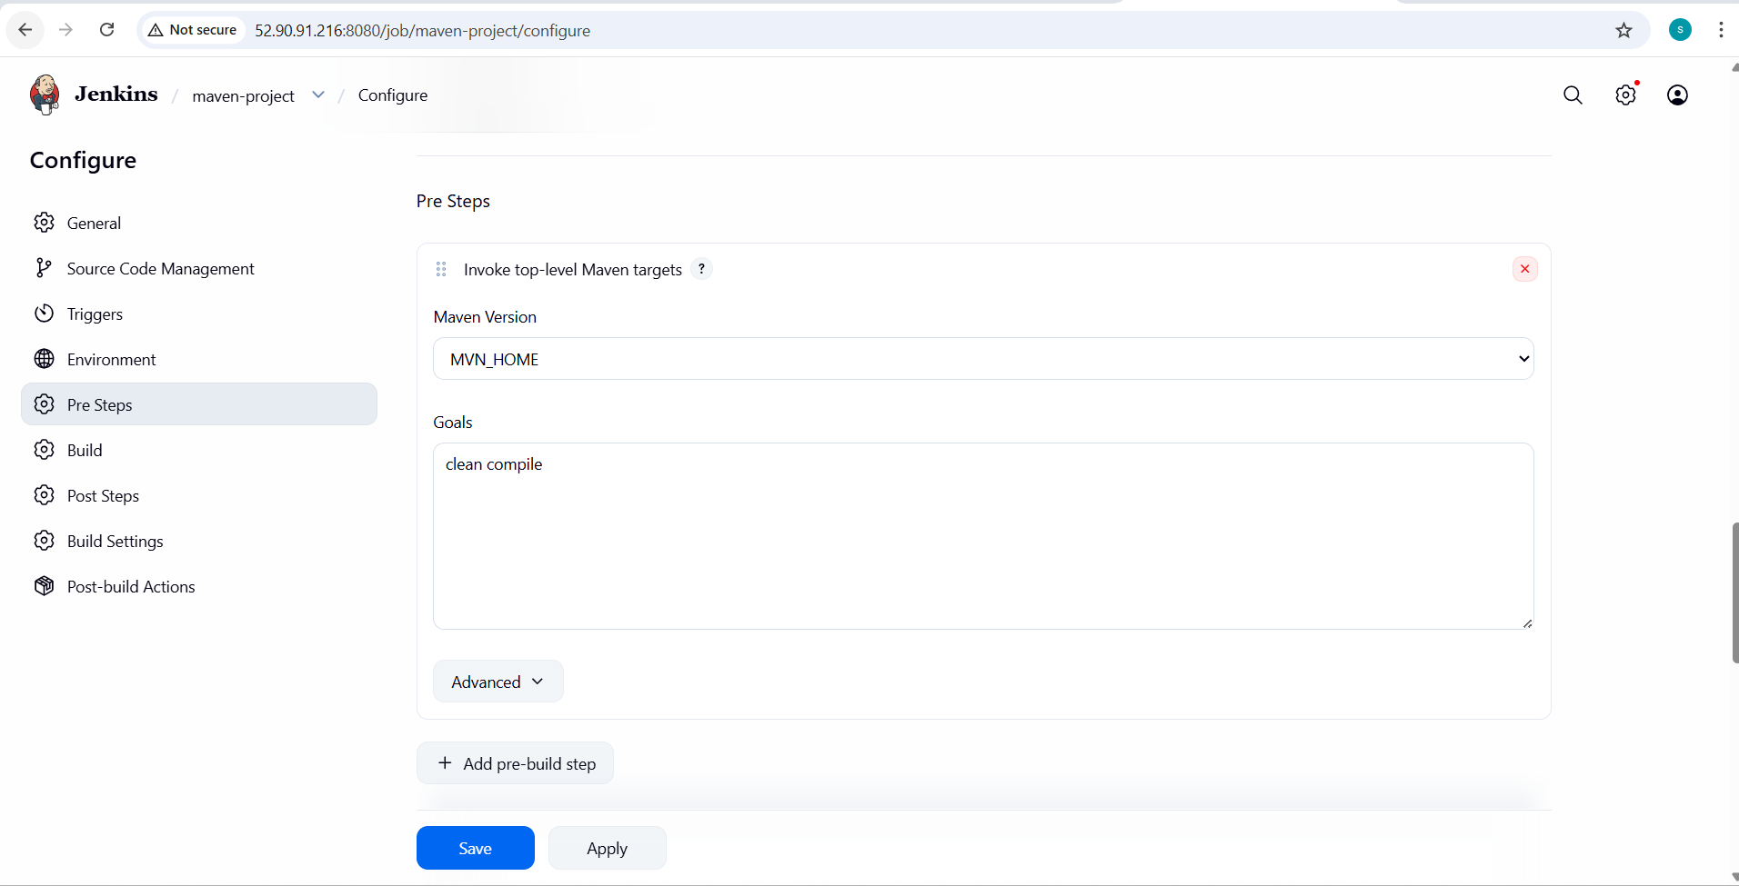

Step 6: Save the Job
Click **Save**.
3. Validation Steps
Validation Step 1: Build Execution
1. Click **Build Now**
2. Open **Console Output**
You should see:
* Git clone logs:
Cloning repository https://github.com/betawins/java-Working-app.git
* Maven compile logs:
mvn clean compile
BUILD SUCCESS
Validation Step 2: Check Workspace
Go to:
Jenkins → Job → Workspace
Confirm:
* `pom.xml` exists
* `target/` directory is created
- Validation Step 3: Job Status
* Jenkins job should show:
* **SUCCESS**
* Both stages executed without errors

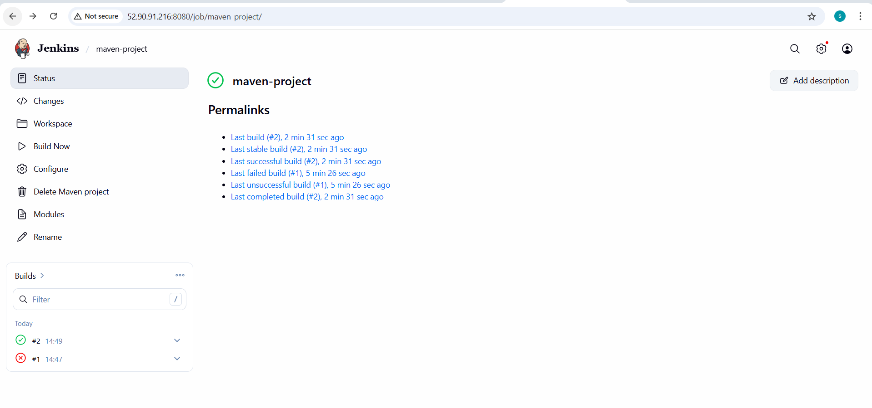

- Use the same code and create a parameterized job in Jenkins with:
Stage 1: Git cloneStage
2: Maven Compilation Code:
https://github.com/betawins/java-Working-app.git

- What are the global variables in Jenkins?

- Jenkins provides a set of global variables that are automatically available during job execution. These variables are used to obtain information about the build, job, workspace, node, and source code. Global variables help in making Jenkins jobs and pipelines dynamic, reusable, and environment-aware
1. Built-in Environment Variables (Global for Jobs)
Built-in environment variables are predefined by Jenkins and are available in all types of jobs such as Freestyle, Maven, and Pipeline jobs. These variables provide runtime information about the current build and Jenkins environment.
Some important built-in environment variables include:
- BUILD_NUMBER – Represents the current build number of the job.
- BUILD_ID – A unique identifier assigned to each build.
- BUILD_TAG – A unique tag generated by Jenkins for the build.
- JOB_NAME – The name of the Jenkins job being executed.
- WORKSPACE – The directory path where the job is executed.
- JENKINS_HOME – The home directory where Jenkins stores configuration and data.
- NODE_NAME – The name of the Jenkins node or agent running the job.
- EXECUTOR_NUMBER – The executor number that is running the build.
- BUILD_URL – The web URL of the current build.
- JOB_URL – The web URL of the Jenkins job.
- GIT_COMMIT – The commit ID of the source code being built.
- GIT_BRANCH – The Git branch name used for the build.

2. Pipeline Global Variables (Groovy Variables)
Pipeline global variables are available only inside Jenkins pipelines written using Declarative or Scripted Pipeline syntax. These variables are provided by Jenkins to interact with pipeline execution and control flow.
Important pipeline global variables include:
- env – Provides access to all environment variables within the pipeline.
- params – Used to access parameters passed to the build.
- currentBuild – Provides information about the current build, such as build number and build status.
- steps – Allows execution of pipeline steps.
- scm – Represents the source control configuration used by the pipeline.
These variables enable better control, monitoring, and customization of pipeline execution.

- Conclusion
Global variables in Jenkins play a crucial role in automating and managing CI/CD pipelines. Built-in environment variables provide essential build-related information across all job types, while pipeline global variables offer advanced control and flexibility within Jenkins pipelines. Together, they help in creating efficient, dynamic, and maintainable Jenkins workflows.

